 南昌大学实验报告

- 实验项目名称
熟悉交换机基本操作和VLAN
二、实验目的
- 深入理解交换机的工作过程
- 掌握交换机的基本操作
- 掌握如何在交换机上建立VLAN
- 实验基本原理

四、主要仪器设备及耗材
PC机、模拟程序。
五、实验步骤
- 网络拓扑结构：

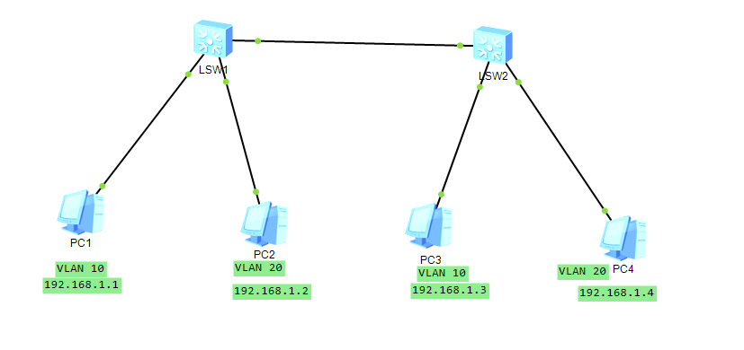
PC | IP地址
PC1 | 192.168.1.1
PC2 | 192.168.1.2
PC3 | 192.168.1.3
PC4 | 192.168.1.4

Switch 0的配置：
- <Huawei>sys
- Enter system view, return user view with Ctrl+Z.
- [Huawei]vlan 10
- [Huawei-vlan10]quit
- [Huawei]vlan 20
- [Huawei-vlan20]quit
- [Huawei]int g 0/0/1
- [Huawei-GigabitEthernet0/0/1]por
- [Huawei-GigabitEthernet0/0/1]port li
- [Huawei-GigabitEthernet0/0/1]port link-t
- [Huawei-GigabitEthernet0/0/1]port link-type a
- [Huawei-GigabitEthernet0/0/1]port link-type access
- [Huawei-GigabitEthernet0/0/1]port de
- [Huawei-GigabitEthernet0/0/1]port default vlan 10
- [Huawei-GigabitEthernet0/0/1]q
- [Huawei]int g 0/0/2
- [Huawei-GigabitEthernet0/0/2]port link-t
- [Huawei-GigabitEthernet0/0/2]port link-type a
- [Huawei-GigabitEthernet0/0/2]port link-type access
- [Huawei-GigabitEthernet0/0/2]port de
- [Huawei-GigabitEthernet0/0/2]port default vlan 20
- [Huawei-GigabitEthernet0/0/2]q
- [Huawei]int g 0/0/3
- [Huawei-GigabitEthernet0/0/3]port t
- [Huawei-GigabitEthernet0/0/3]port link-
- [Huawei-GigabitEthernet0/0/3]port link-type t
- [Huawei-GigabitEthernet0/0/3]port link-type trunk
- [Huawei-GigabitEthernet0/0/3]port t
- [Huawei-GigabitEthernet0/0/3]port trunk a
- [Huawei-GigabitEthernet0/0/3]port trunk allow-pass vlan all
- [Huawei-GigabitEthernet0/0/3]q
- [Huawei]q
- <Huawei>save
- The current configuration will be written to the device.
- Are you sure to continue?[Y/N]y

Switch 1的配置：

- <Huawei>sys
- Enter system view, return user view with Ctrl+Z.
- [Huawei]vlan 10
- [Huawei-vlan10]q
- [Huawei]vlan 20
- [Huawei-vlan20]q
- [Huawei]int g 0/0/1
- [Huawei-GigabitEthernet0/0/1]por
- [Huawei-GigabitEthernet0/0/1]port l
- [Huawei-GigabitEthernet0/0/1]port link-t
- [Huawei-GigabitEthernet0/0/1]port link-type a
- [Huawei-GigabitEthernet0/0/1]port link-type access
- [Huawei-GigabitEthernet0/0/1]port de
- [Huawei-GigabitEthernet0/0/1]port default vlan 10
- [Huawei-GigabitEthernet0/0/1]q
- [Huawei]int g 0/0/2
- [Huawei-GigabitEthernet0/0/2]port link-t
- [Huawei-GigabitEthernet0/0/2]port link-type a
- [Huawei-GigabitEthernet0/0/2]port link-type access
- [Huawei-GigabitEthernet0/0/2]port de
- [Huawei-GigabitEthernet0/0/2]port default vlan 20
- [Huawei-GigabitEthernet0/0/2]q
- [Huawei]int g 0/0/3
- [Huawei-GigabitEthernet0/0/3]port t
- [Huawei-GigabitEthernet0/0/3]port link-
- [Huawei-GigabitEthernet0/0/3]port link-type t
- [Huawei-GigabitEthernet0/0/3]port link-type trunk
- [Huawei-GigabitEthernet0/0/3]port t
- [Huawei-GigabitEthernet0/0/3]port trunk a
- [Huawei-GigabitEthernet0/0/3]port trunk allow-pass vlan all
- [Huawei-GigabitEthernet0/0/3]q
- [Huawei]q
- <Huawei>save
- The current configuration will be written to the device.
- Are you sure to continue?[Y/N]y

- 思考讨论题或体会或对改进实验的建议
本次实验是有点曲折的为什么这么说呢。首先安装eNSP要安
VirtualBox虚拟机应用,WinPcap,如果你的电脑已经安装WinPcap请安装老师的应为等你打开软件的时候求生启动文件.dll。第二个安装eNSP软件会其中系统代理意味着你的电脑浏览器可能因为代理问题没用网络(别问问就是已经重装了系统)。本次实验是在虚拟机安装应用完成的。不过总的来说还是很有帮助了解了网络Vlan的设置方法。
八、参考资料
打开eNSP提示由于找不到packet.dll,无法继续执行代码 的解决办法

